E-Commerce Sales & Profit Intelligence Dashboard

Developer : Priyadharshini Naresh D
Cohort : FNB16
Program : AI-driven Data Analytics

Introduction

The Project is to design and develop an end-to-end Retail Sales & Profit Intelligence Dashboard using Microsoft Excel. Engineered a complete analytics pipeline in Excel: from data cleaning and multi-table integration using XLOOKUP/VLOOKUP, to KPI modeling for Sales, Cost, Profit, and Discount Impact. Built an interactive dashboard with Pivot Tables, charts, and slicers to enable stakeholders to identify trends, track margins, and optimize discount strategies in real time. The final deliverable supports business decision-making by uncovering sales patterns, profit drivers, and discount effectiveness.

Project Objective

- Cleaned and standardized raw transactional data to ensure accuracy and consistency
- Resolved missing and inconsistent values using Excel data validation and formulas
- Integrated multiple datasets with XLOOKUP/VLOOKUP to create a unified master table
- Calculated core business metrics including Sales, Cost, Profit, and Discount Value
- Conducted descriptive statistical analysis to identify trends, outliers, and performance drivers
- Built Pivot Tables to summarize sales, profitability, and customer behavior by category and region
- Designed an interactive dashboard with dynamic charts and slicers for real-time business monitoring
- Delivered actionable insights to guide management decisions on inventory, pricing, and regional strategy

Project Description
This project focuses on cleaning, integrating, analyzing, and visualizing an e-commerce retail dataset using Microsoft Excel. The objective is to transform raw transactional data into meaningful business insights through data cleaning, Excel formulas, Pivot Tables, descriptive statistics, and an interactive dashboard. The project helps management understand sales performance, profitability, customer behavior, and regional trends.

Technology Stack
- Platform: Microsoft Excel - Advanced Analytics & BI Modeling
- Data Modeling: XLOOKUP, VLOOKUP, INDEX-MATCH for relational data integration
- Aggregation & Analysis: Pivot Tables with calculated fields for KPI computation
- Visualization: Dynamic Pivot Charts with conditional formatting for trend analysis
- Interactivity: Slicers and Timelines for user-driven data exploration
- Data Processing: Power Query, Text-to-Columns, Remove Duplicates, and statistical functions for data cleaning & transformation

Dataset Overview
The dataset contains sales transaction information including:
Categorical Dimensions:
- Identifiers: Transaction ID, SKU, Customer ID
- Product Hierarchy: Product Category, Sub-Category
- Geographic Segmentation: Region, Store Type, Location
- Transaction Attributes: Payment Type, Customer Segment

Quantitative Measures:
- Revenue Metrics: Sales Revenue, Discount Value, Net Sales
- Volume Metrics: Units Sold, Quantity per Transaction
- Temporal Fields: Year of Sale, Order Date, Month

Data Cleaning & Transformation
To ensure data accuracy and reliability, the following steps were executed:
- Eliminated duplicate records to prevent skewed analysis
- Identified and resolved missing values and data inconsistencies using validation rules and formulas
- Standardized data formats for dates, currency, and categorical fields across all tables
- Aggregated data with Pivot Tables to summarize sales, profit, and customer metrics
- Enabled dynamic analysis by applying filters and slicers for interactive data exploration

Data Cleaning and Transformation Screenshots:
Imputed missing Cost values using average-based replacement to maintain dataset completeness
Audited data quality by identifying and correcting missing entries and inconsistencies
Standardized numerical formatting by applying currency and percentage styles for clarity and consistency

Using Find and Replace
Use this to quickly standardize your Customer ID format from the image.
1. Select the column with IDs like C-1464
2. Press Ctrl + H
3. Find what: C- → Replace with: Cust → Click Replace All
4. Result: C-1464 becomes Cust1464
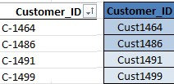

Using IF function to fill blank Loyalty Level
If Loyalty Level column has blanks, fill with "Unknown":
Formula: =IF(ISBLANK(I2), "Unknown", I2)
Replace I2 with your Loyalty Level cell. Drag down.
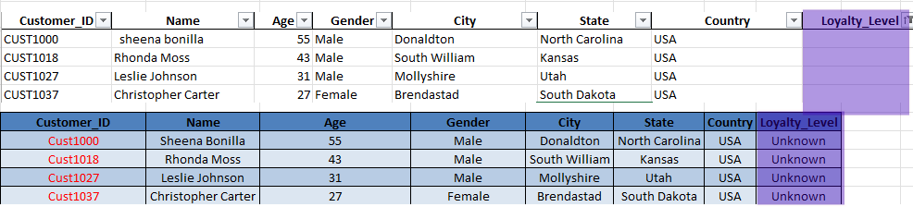

Using TRIM, CLEAN, PROPER
These fix messy text. Combine them for best results.
Formula: =PROPER(TRIM(CLEAN(A2)))
- CLEAN: Removes non-printable characters like line breaks
- TRIM: Removes extra spaces between words, leaves single spaces
- PROPER: Capitalizes first letter of each word
Ex: ` sheena bonilla ` becomes Sheena Bonilla
Text to Columns to split names
To separate sheena bonilla into First Name + Last Name:
1. Select the Name column
2. Go to Data tab → Text to Columns
3. Choose Delimited → Next
4. Check Space → Next → Finish
5. Result: sheena in one column, bonilla in the next
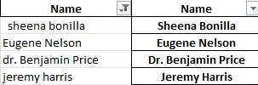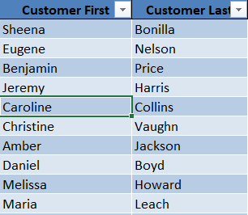

IF function to fill blank Quantity with Average
If Quantity column has blanks, fill with the average of that column:
Formula: =IF(F2="", AVERAGE(F:F), F2)
Replace F2 with your Quantity cell. F:F is the whole Quantity column.

Conditional Formatting for Cost, Stock, other numbers
To highlight high/low values:
1. Select your Cost or Stock column
2. Home → Conditional Formatting → Color Scales → pick one
3. For custom rules: Conditional Formatting → New Rule → Format only cells that contain
- Ex: Cell Value > 1000 → set fill to red
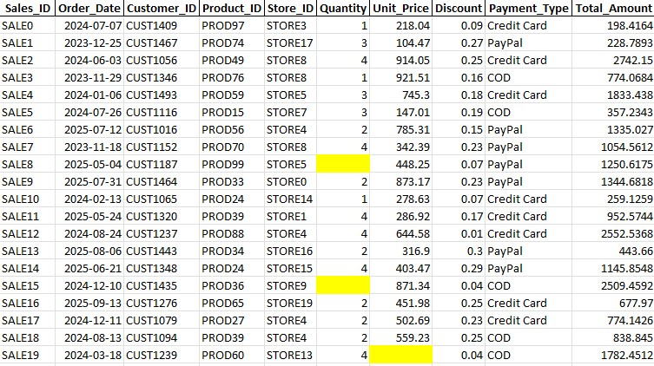

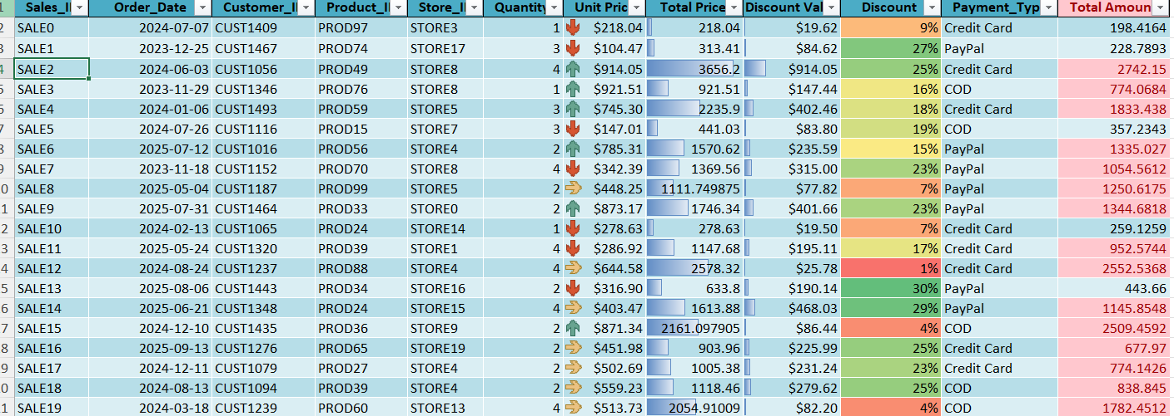

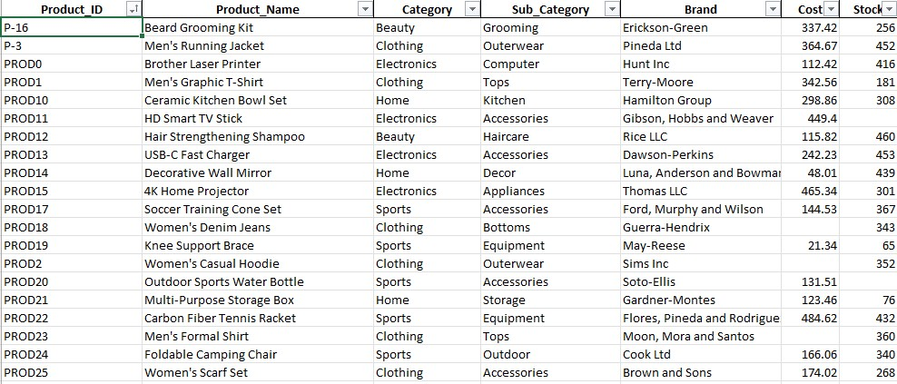

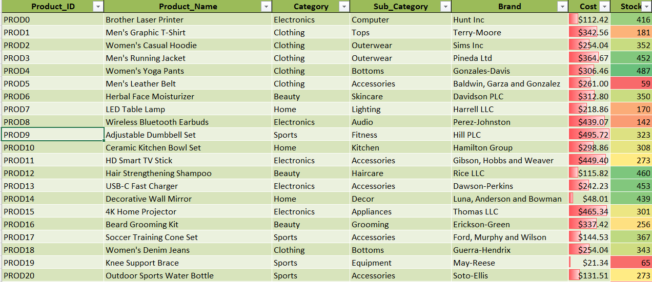

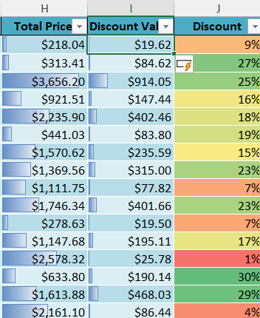

Descriptive Statistics
Performed descriptive statistical analysis using Excel Analysis Tool Pak to evaluate central tendency and distribution. Key metrics included:
- Mean, Median, Mode
- Standard Deviation, Variance
- Kurtosis, Skewness

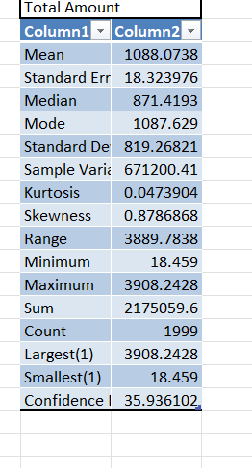

Dashboard Components
The dashboard includes:
- Category-wise analysis of sales and profit to identify top-performing product lines
- Regional performance breakdown highlighting geographic sales and profitability trends
- Store type comparison to evaluate performance across different retail formats
- Monthly sales trend visualization for tracking seasonality and growth patterns
- Interactive slicers enabling dynamic filtering by date, region, category, and store type
- Key Performance Indicators (KPIs) summarizing critical metrics at a glance

Dashboard Development
An interactive dashboard was developed to analyse:
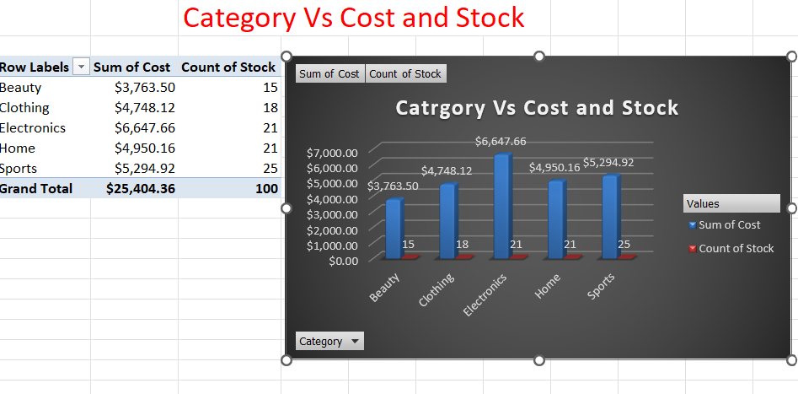
- Conducted category-wise revenue analysis to compare sales performance across all product lines
- Identified top and bottom-performing categories based on total revenue and profit contribution
- Evaluated each category’s share of overall sales to understand revenue concentration and growth drivers
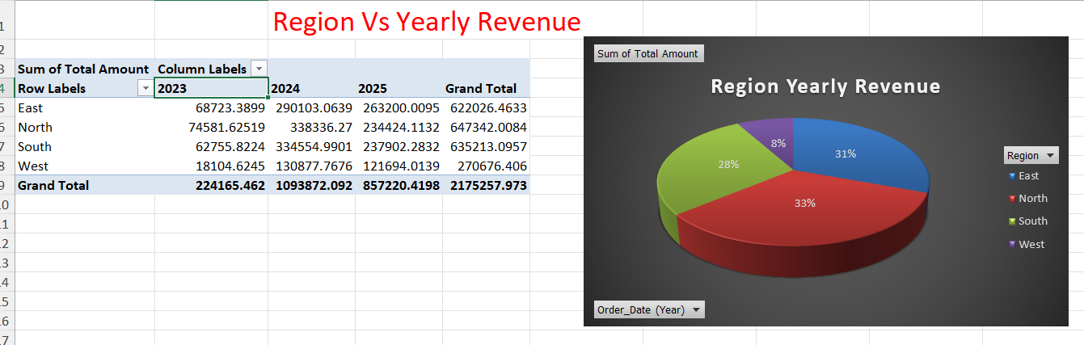

- Evaluated regional sales performance to assess geographic revenue distribution and profitability
- Identified top revenue-generating regions to pinpoint key markets and growth opportunities
- Analyzed regional sales trends to uncover patterns, seasonality, and areas for targeted expansion

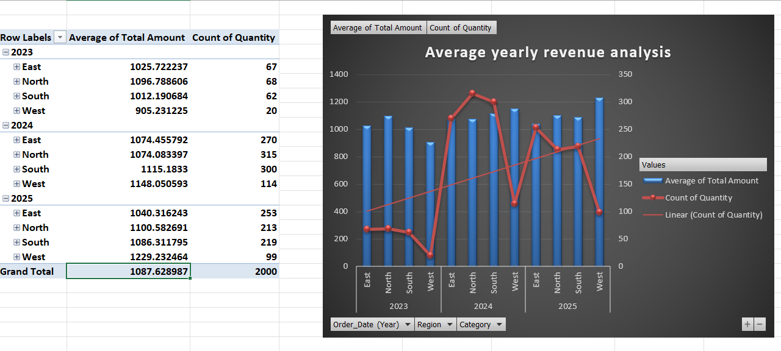

- Conducted year-over-year revenue comparison across product categories to evaluate growth trajectories
- Identified categories with consistent growth by analyzing multi-year performance trends
- Assessed category performance trends over time to detect seasonality, expansion, and decline patterns
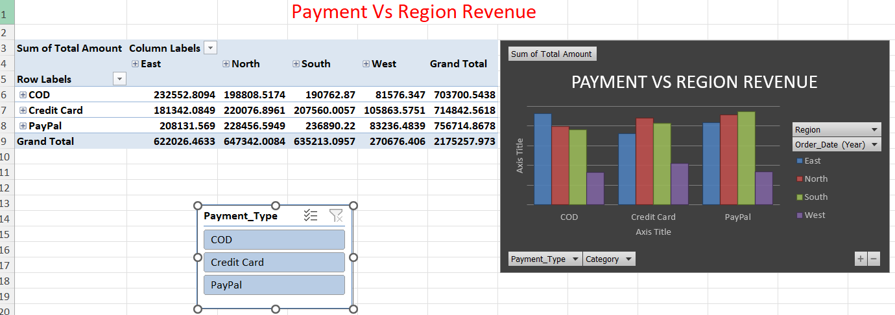

- Analyzed revenue distribution by payment method to evaluate channel performance and customer behavior
- Identified the most utilized payment option based on transaction volume and total revenue contribution
- Measured payment-wise sales contribution to determine channel efficiency and customer preferences

- Examined multi-year revenue growth to assess long-term business trajectory and performance
- Identified upward and downward sales trends using year-over-year comparisons and growth rate analysis
- Evaluated overall business performance across time periods to measure sustainability and scalability

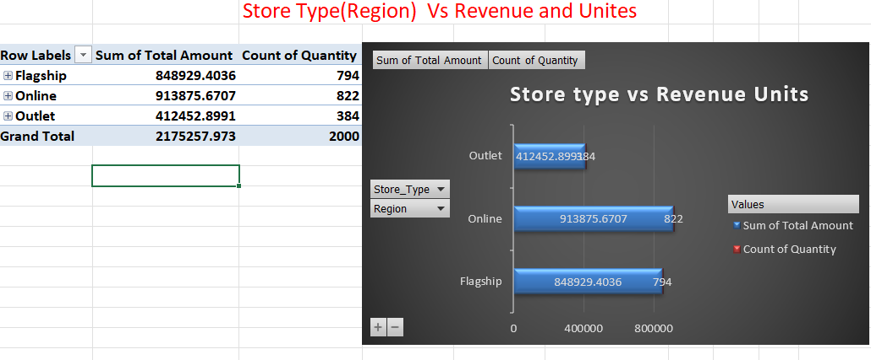
- Conducted multi-year revenue comparison across store types to evaluate channel performance
- Identified the most profitable store format based on total revenue and profit margins
- Assessed store-wise contribution to annual revenue to guide channel strategy and investment

Key Insights

- Total Sales Revenue: $2,170,907.46 with Total Profit: $890,321.28
- Regional Performance: South region delivered the highest profit contribution
- Performance Category: Sports category led in total sales revenue
- Customer Behavior: Purchasing patterns vary significantly by loyalty tier
- Channel Analysis: Store type directly impacts sales performance
- Demand Patterns: Monthly trends highlight clear seasonal peaks and troughs

Learning Outcomes
- Advanced Excel dashboard development using Pivot Tables, charts, slicers, and KPI cards for interactive reporting
- Mastered data cleaning and transformation techniques including handling missing values, removing duplicates, and standardizing formats
- Applied business data analysis to extract trends, calculate core metrics, and derive actionable insights
- Strengthened data visualization and reporting skills to communicate findings clearly to stakeholders

Conclusion

This project successfully leveraged Microsoft Excel for end-to-end data analysis, including data cleaning, integration, statistical analysis, Pivot Table reporting, and interactive dashboard development. The resulting dashboard delivers actionable business insights that enable data-driven decision-making and support continuous improvement in organizational performance.

Dashboard Screenshot:

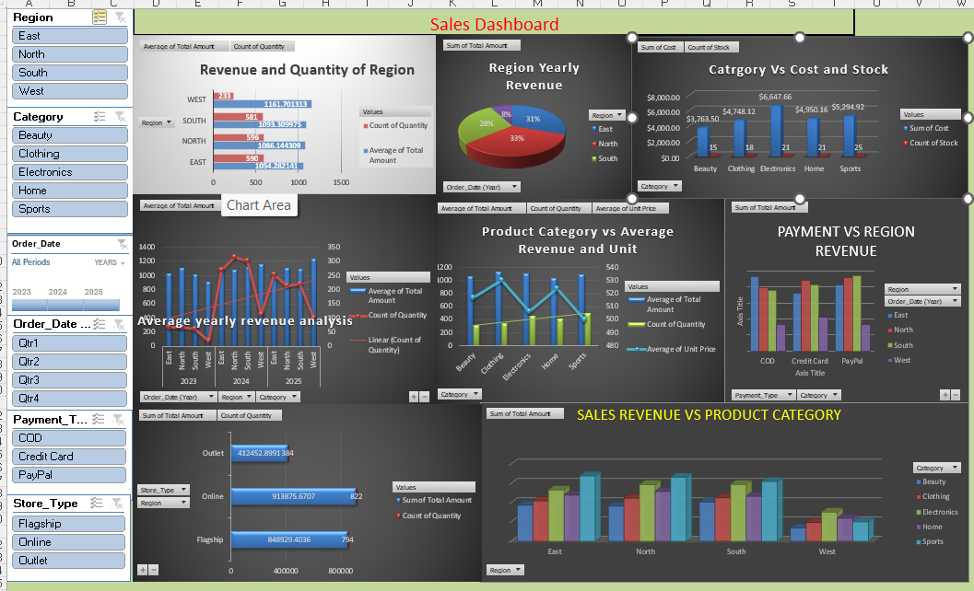

Acknowledgment

I extend my sincere gratitude to Microsoft for Excel, whose robust tools for data cleaning, statistical analysis, and dashboard development were instrumental to this project. I also thank GitHub for hosting resources and the broader online learning community for the tutorials and documentation that supported its successful completion.

Author:
Priyadharshini Naresh D

